**Ideation Phase**

**Brainstorm & Idea Prioritization Template**

|  |  |
| --- | --- |
| Date | 25-september- 2023 |
| Team ID | NM2023TMID05059 |
| Project Name | Data Titans : Unearthing Trends from LinkedIn Influencers. |
| Maximum Marks | 4 Marks |

**Brainstorm & Idea Prioritization Template:** Brainstorming provides a free and open environment that encourages everyone within a team to participate in the creative thinking process that leads to problem solving. Prioritizing volume over value, out-of-the-box ideas are welcome and built upon, and all participants are encouraged to collaborate, helping each other develop a rich amount of creative solutions.

**Step-1: Team Gathering, Collaboration and Select the Problem Statement**

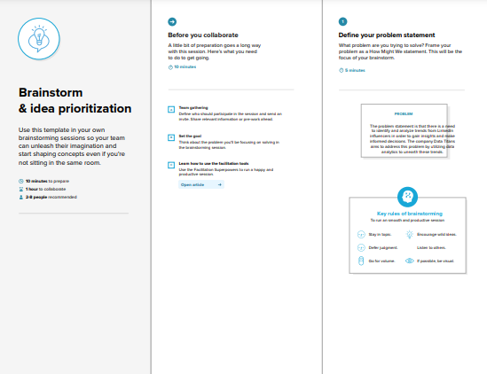

# Problem : The real problem is there is no proper visualizations for analysing data. So by using “IBM COGNOS ANALYSIS” we can provide our solutions through various visualizations for our topic “Data Titans : Unearthing Trends from LinkedIn Influencers”

**Step 2 : Brainstorm**

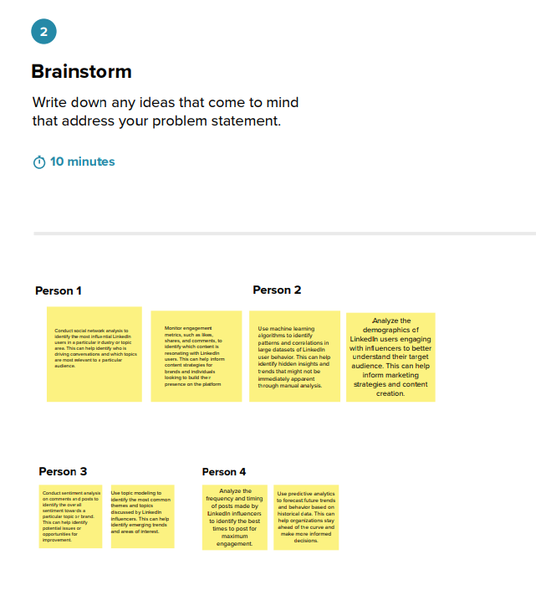

**Step 3 : Group Ideas**

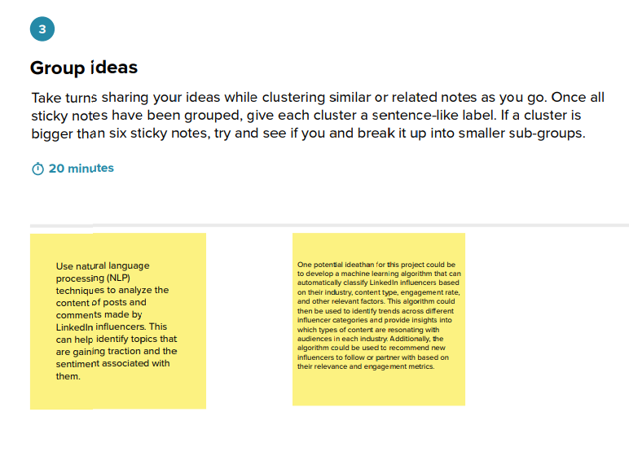

**Step 4 : Prioritize**

